A Practical Guide to Testing and Debugging Spark Applications with Jupyter and the Spark History Server
Modern data engineering demands a robust workflow that supports both interactive development for rapid iteration and deep performance analysis for building scalable solutions. An effective process must bridge the gap between writing code and understanding how it behaves under load, ultimately de-risking complex data projects and reducing their total cost of ownership. This guide details a unified workflow that leverages two critical tools in the Spark ecosystem: JupyterLab for iterative, component-level testing, and the Spark History Server for post-execution diagnostics. By integrating these tools, development teams can build, test, and troubleshoot Spark applications more effectively, ensuring both logical correctness and high performance.

1. Interactive Development and Unit Testing with JupyterLab
In the Spark ecosystem, an interactive development environment is a strategic asset, not just a convenience. JupyterLab, in particular, empowers developers to move faster by facilitating rapid prototyping, immediate logic validation, and isolated testing of application components. This approach significantly accelerates the development lifecycle by allowing for quick, iterative cycles of coding and testing before a full-scale deployment is ever attempted.

1.1. Structuring the Development Environment
A well-organized project structure is the foundation for any maintainable and scalable data application. A best-practice approach, as seen in the JupyterLab interface, involves a clear separation of concerns into distinct directories.
This structure typically includes:
- apps: For compiled application artifacts, such as JAR files.
- data: For raw and processed datasets.
- notebooks: For all interactive development and exploration work, often subdivided by function (e.g., DataExploration, FeatureEngineering).
- scripts: For shell scripts or automation helpers.
This separation of concerns is critical for professional data engineering. It enables automated CI/CD pipelines, simplifies dependency management, and allows different team members—such as data engineers and data scientists—to work in parallel without creating conflicts in the codebase.
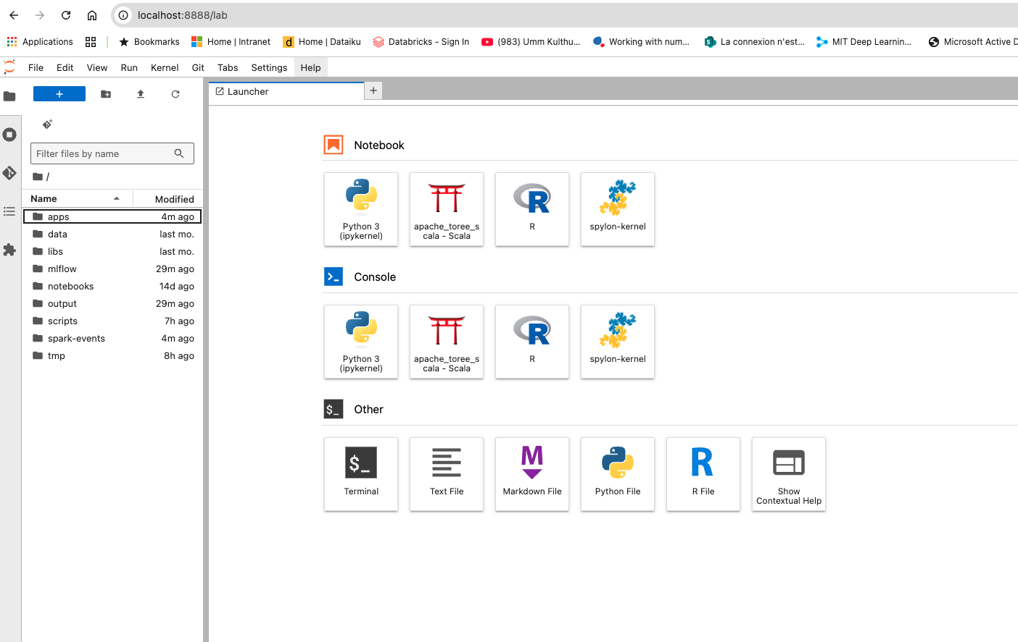

1.2. Integrating Compiled Application Code
To ensure consistency between development and production, it is crucial to test the exact code that will be deployed. Jupyter notebooks with a Scala kernel support the %AddJar magic command, which provides a direct and efficient way to achieve this.
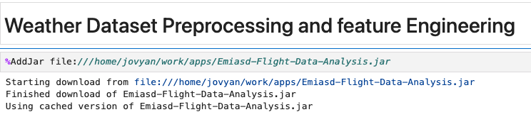
The command %AddJar file:///.../Emiasd-Flight-Data-Analysis.jar dynamically loads the compiled application JAR into the Spark session's classpath. This approach is non-negotiable for ensuring a single source of truth; it eradicates the entire class of "it worked on my machine" bugs that plague less disciplined teams. By importing and executing classes from the production codebase directly within the notebook, we guarantee that the logic validated interactively is the same logic that will run in the final spark-submit job.

1.3. Executing and Validating Code in Isolation
With the development environment and application code integrated, developers can test specific components of their application in a controlled, cell-by-cell manner. This process is fundamental for debugging complex transformations and validating business logic.
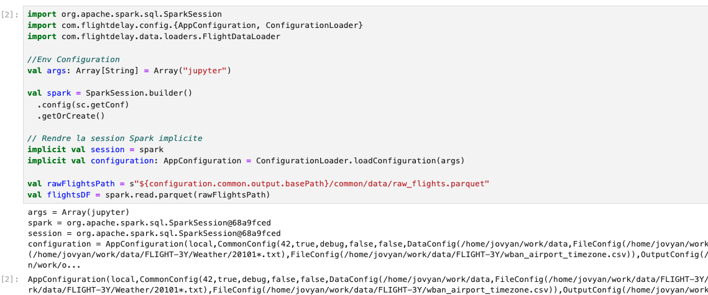

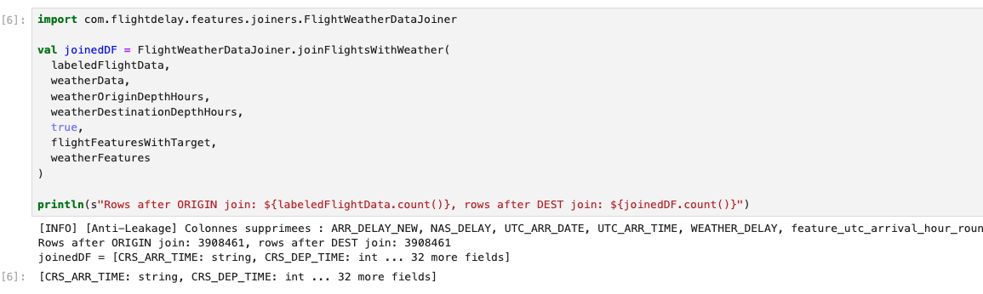

The workflow for testing a feature typically follows these steps:
- Spark Session Initialization: The code first initializes a Spark session. Critically, it calls a shared ConfigurationLoader.loadConfiguration(args) method, passing a specific "jupyter" argument. This is a key design pattern for environment-agnostic code, as it allows developers to reuse production configuration logic while easily overriding specific parameters (like file paths) for local testing.
- Component Execution: A specific component, such as the FlightWeatherDataSourceJoiner, is imported from the compiled JAR. The relevant method, joinFlightsWithWeather, is then executed with the necessary DataFrame inputs. This isolates the test to a single, manageable unit of work.
- Immediate Validation: After execution, a simple but powerful validation step is performed. The println statement outputs the row counts before and after the join, revealing Rows after ORIGIN join: 3908461, rows after DEST join: 3908461. The identical row count is a critical piece of feedback. It confirms that the join is behaving as an enrichment (a 1-to-1 or N-to-1 lookup) and is not inadvertently filtering rows or causing a row explosion due to a faulty join key—a crucial sanity check that provides immediate confidence in the logic.
This interactive, cell-by-cell execution is fundamental for effective data exploration, unit testing feature engineering logic, and efficiently troubleshooting specific functions. With the logic now validated for correctness in an interactive environment, the focus must shift to ensuring it performs efficiently at scale. For this, we turn to the Spark History Server, the definitive record of the application's execution.

2. Deep Dive Analysis with the Spark History Server
The Spark History Server is the definitive tool for post-mortem analysis of an application's performance. It enables the crucial transition from asking, "Is the logic correct?" to "Will the logic scale?" Whether an application was run interactively or via spark-submit, the History Server provides the detailed execution record necessary to ensure its production viability by identifying and resolving performance bottlenecks.
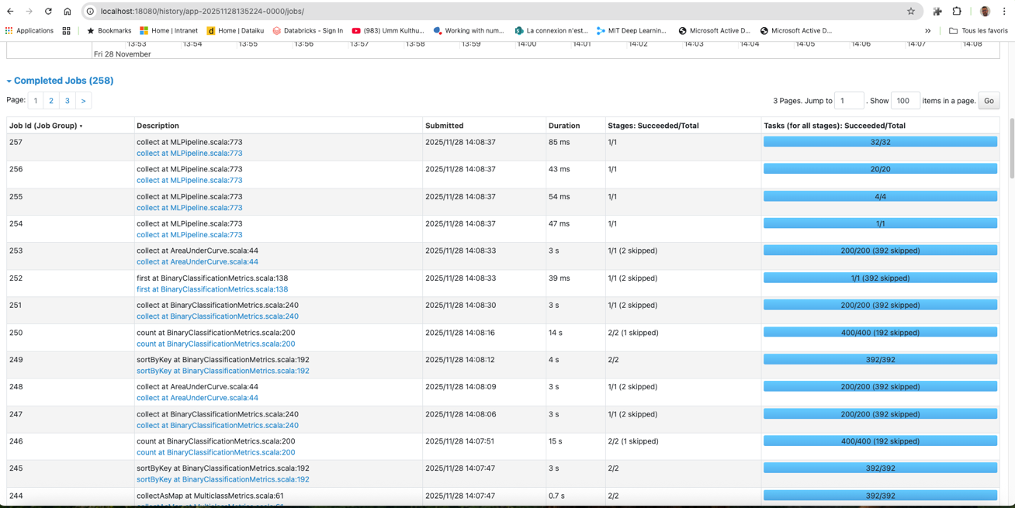

2.1. From Application Overview to Job-Level Details
Analysis begins at a high level. The main History Server page provides a summary of completed applications, including the "Flight Delay Prediction App," its duration, and submission time.
From here, we drill down into the "Completed Jobs" view, which breaks down the application into a sequence of Spark Jobs. This view is the starting point for a "top-down" debugging approach. The job descriptions, such as collect at Ml.Pipeline.scala:773, are invaluable; they link execution directly to a line in the source code. An engineer can immediately identify the longest-running jobs and know precisely which action in the code triggered them, providing a clear path for investigation.

2.2. Visualizing Execution Flow with the DAG
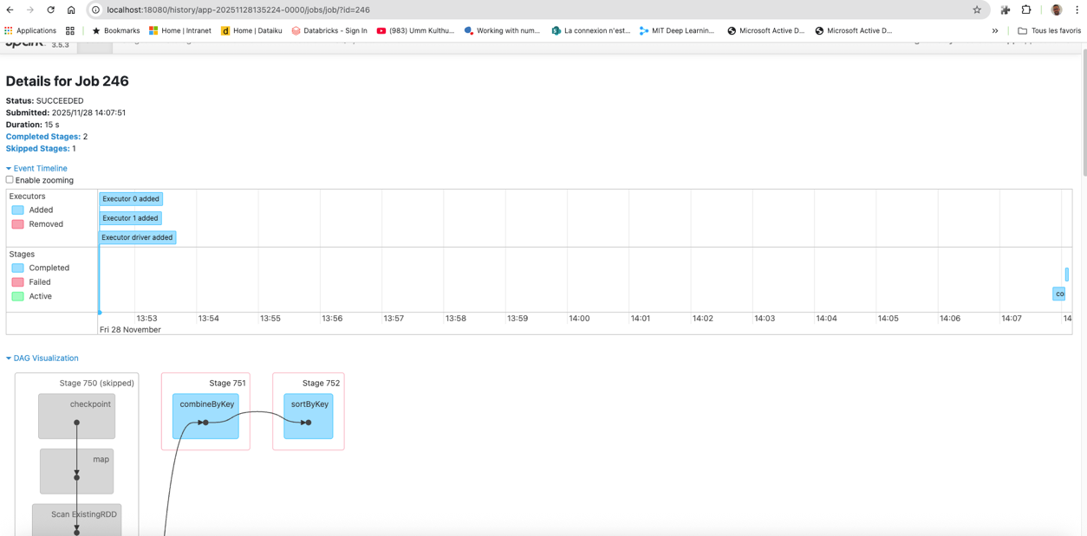

For each job, the Spark History Server provides a Directed Acyclic Graph (DAG) visualization. The DAG is a map of the data flow, breaking the job into stages—groups of tasks that can be executed without data redistribution.
The lines connecting stages in the DAG, such as the one between Stage 751 and Stage 752, represent a shuffle boundary. The presence of operations like combineByKey and sortByKey are classic indicators of a shuffle, where Spark must redistribute data across the network. This is the most common and severe performance bottleneck in distributed processing, and the DAG makes these boundaries immediately obvious

2.3. Diagnosing Bottlenecks with Stage and Task Metrics

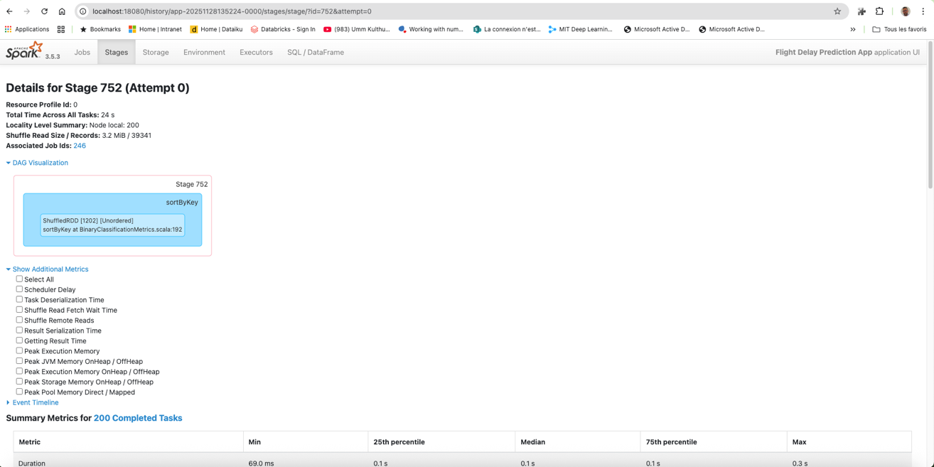

Drilling down into a specific stage, like Stage 752, reveals the granular metrics needed to diagnose the root cause of a slowdown.
Key metrics available on this page include:
- Total Time: The wall-clock time for the stage to complete.
- Shuffle Read / Write: The volume of data transferred between executors. High shuffle I/O is a primary indicator of a performance bottleneck.
- Summary Metrics (e.g., Duration percentiles): A statistical summary of task-level metrics. A large variance between the median and max duration is a classic sign of data skew, where a few tasks are straggling because they are processing a disproportionate amount of data.

2.4. Optimizing Queries via the Physical Plan

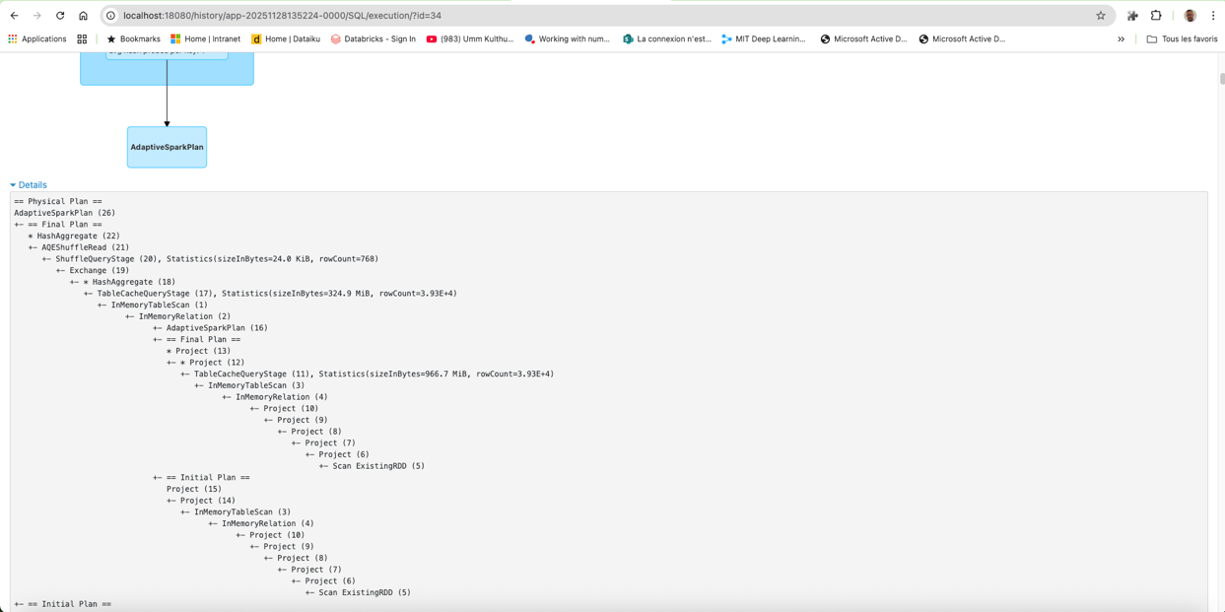
For jobs involving DataFrame or SQL operations, the History Server provides the query execution plans. The Physical Plan is the ultimate ground truth of Spark's execution, detailing the final sequence of operations that will run on the cluster.
Senior engineers use this view to verify their optimizations. By examining the AdaptiveSparkPlan tree, they can confirm whether their intentions were realized by Spark's Catalyst optimizer. Did a broadcast hint result in a BroadcastHashJoin? Did filtering on a partitioned column result in partition pruning? The plan, showing operations like HashAggregate, Exchange, and TableScan, overrides any assumptions and reveals exactly how the query is being executed.
These multi-layered diagnostics, from application overview to the physical plan, are not merely informational. They are the critical inputs that power the second half of our robust development loop: refinement and re-validation.

3. The Unified Workflow for Robust Development
The true power of these tools is unlocked not by using them in isolation, but by integrating them into a cohesive development lifecycle. This unified workflow creates a continuous feedback loop where interactive testing in Jupyter informs performance analysis in the Spark History Server, and vice-versa, leading to more robust and efficient applications.
3.1. The Development and Debugging Lifecycle

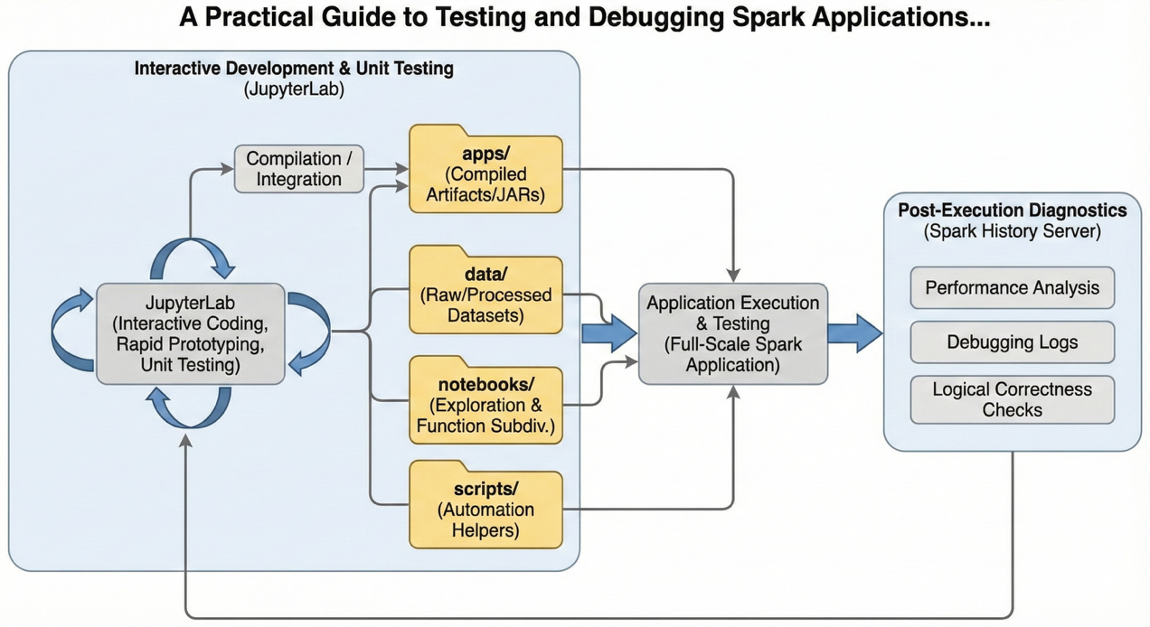
This end-to-end workflow enables a structured and iterative approach to building high-quality Spark applications:
- Iterate and Validate in Jupyter: A developer writes and tests discrete units of logic, leveraging compiled JARs for consistency. Immediate outputs (println, printSchema) provide rapid validation and debugging.
- Execute Full Run: Once the logic is confirmed, the full application is run via a larger notebook execution or a spark-submit command to generate the necessary event logs.
- Analyze in Spark History Server: The resulting application run is analyzed to identify performance bottlenecks, inspect query plans, and ensure the application runs efficiently at scale.
- Refine and Repeat: Insights from the History Server (e.g., a slow join or an inefficient shuffle) feed back into the development process, where the specific code can be isolated and refined again in Jupyter. This cycle repeats until both correctness and performance goals are met.

3.2. Core Benefits of this Integrated Approach
Adopting this integrated workflow yields significant strategic advantages for any data engineering team:
- Increased Development Velocity: This approach slashes the feedback loop on logic errors from hours to seconds, which is a critical competitive advantage. Developers are no longer forced to wait for long-running batch jobs to fail before they can begin debugging.
- Enhanced Code Quality and Reliability: By testing production code directly and validating performance with the History Server, teams build defensible, auditable, and performant data pipelines that are more resilient in production.
- Proactive Performance Optimization: This workflow empowers developers to move from a reactive "fix-it-when-it-breaks" mindset to proactively designing for performance. It prevents costly post-deployment firefighting and emergency cluster resizing by ensuring that applications are built to be efficient from the start.
This combined workflow represents a best practice for professional Spark development, ensuring that applications are built to be both correct and efficient from the ground up.

4. Conclusion
Building high-quality, scalable Spark applications requires a development methodology that embraces both iterative, logic-focused testing and deep, post-mortem performance analysis. By mastering the interplay between the interactive environment of JupyterLab and the powerful diagnostic capabilities of the Spark History Server, development teams can create a virtuous cycle of continuous improvement. This unified workflow significantly improves efficiency, reduces bugs, and empowers engineers to build sophisticated, high-performance data applications that can meet the demands of any modern data platform.

